|  |  |
| --- | --- |
|  | *SMA Runbook Toolkit (SMART)*  *Documentation and Conversion Helper 2.01*  *For Orchestrator Runbooks* |

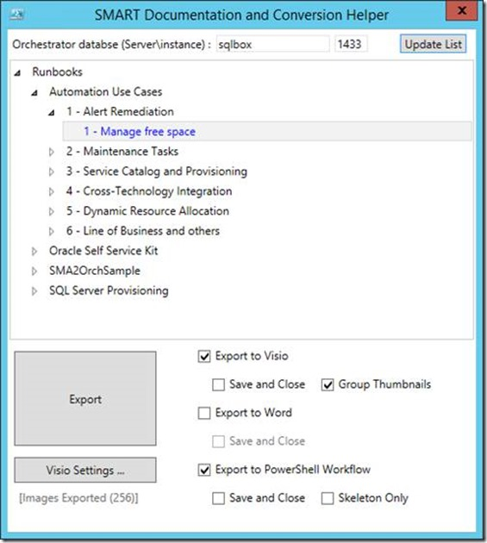

Contents

Overview of the SMART Documentation and Conversion Helper 3

Tools replaced 4

Package content 4

Prerequisites and preliminary steps 5

Prerequisites 5

Exporting the images from the Integration Packs 5

How to use the tool 8

Details on the different options in the user interface 8

A few sample outputs 9

Example 1 9

Example 2 12

Known issues 18

Version history 19

# Overview of the SMART Documentation and Conversion Helper

This PowerShell-based tool lets you export Orchestrator Runbooks as Visio diagrams, Word documents and/or PowerShell Workflows. You can view some sample outputs later in this document.

Components exported as of v2.01 are as follow:

|  |  |
| --- | --- |
| ***Visio Export*** | * Title of the Runbook * Activities and their names/thumbnails/description (description is displayed as a callout in the Visio diagram, attached to the shape of the activity) * Links and their names/colors * Looping and their interval   **Note:** Thumbnails and activities are grouped in the Visio diagram, for easy manipulation of the diagram before saving the final layout (grouping and automatic saving can be disabled in the application settings). |
| ***Word Export*** | * Title of the Runbook * Listing of the activities, thumbnail, with their name, descriptions, dependencies (activities and their thumbnails, variables and their value – unless encrypted). The details of the activities are also provided (same content as the “full mode” in PowerShell export, see below) |
| ***PowerShell Workflow Export*** | There are two export modes:   * Skeleton export : Basically, this is the structure of the source Runbook branches and conditions in a PowerShell Workflow syntax, with “workflow”, “param”, “parallel”, “sequence” and the potential “if” conditions. * Full export (default mode): The same structure as “skeleton mode” is exported, but with details about all properties of all activities in the source Orchestrator Runbook. Specific parsing is done for Run .NET Script activities (including PowerShell), Initialize Data, Return Data, Schedules, Counters. For each properties, published data and variables are replaced by their actual display names (no GUIDs!), so you can easily relate to what they mean. At the bottom of the script, the tool provides a summary of variables, counters, schedules, initialize data activities, return data activities, loops, merging branches. That way, you have a list of items potentially worth investigating when porting your Runbook. |

Please send any suggestions, bugs and overall feedback to [brunosa@microsoft.com](mailto:brunosa@microsoft.com)

## Tools replaced

As of v2.01, The SMART Documentation and Conversion Helper supersedes and replaces both the “Orchestrator Visio and Word Generator” (last version being v1.51) and the “SMART Runbook Conversion Helper” (last version being v1.0)

|  |  |
| --- | --- |
| *As an Orchestrator Visio and Word Generator user, you now get:* | * PowerShell Workflow export capabilities, which might be interesting as you get into SMA. * Updated Word export capabilities : It now leverages the same subroutines as the PowerShell Worfklow export, and is much more clean and detailed than the Word export in OVWG * Access to the script source: The Orchestrator Visio and Word Generator was based on .NET, the updated/new tool is now fully based on PowerShell. So it makes it easier to look at the source script, and update it for any issues or enhancements, or update it to work with other versions of Visio/Word, etc. If you do make any updates and enhancements, please make sure you embrace the community spirit and share them back! |
| *As a SMART Runbook Conversion Helper user, you now get:* | * Visio and Word export in the same interface |

## Package content

The download package contains four files

* **SMART-DocumentationConversionHelper.ps1**: This is the main tool, now provided as a PowerShell script, leveraging Windows Presentation Foundation (WPF) to provide a user interface
* **SMART-DocumentationConversionHelper-ImageExport.ps1**:This additional script is used to export images thumbnails from the Orchestrator integration packs DLLs – see more instruction further down in this document
* **Default.jpg:** This image will be used as the default thumbnail, when the corresponding thumbnail for an activity cannot be found, or if you have not run the export process at all.
* **SMART Documentation and Conversion Helper.docx:** This file!

# Prerequisites and preliminary steps

## Prerequisites

* The tool must be run on a 64-bit machine with PowerShell – The script was written with PowerShell 4.0 on a Windows Server 2012 R2 machine, but tested on Windows 7 and higher
  + On pre-Windows Server 2012 R2 operating systems, you will need to install Windows Management Framework 4.0, which also requires [.NET Framework 4.0](http://www.microsoft.com/download/details.aspx?id=30653) : <http://www.microsoft.com/en-us/download/details.aspx?id=40855>
* For Visio export, Visio 2013 (32-bit) must be installed on the machine where the tool is running
* For Word export, Word 2013 (32-bit) must be installed on the machine where the tool is running
* For thumbnail exports, Visual C++ 2010 redistributable package needs to be installed:
  + 32-bit : <http://www.microsoft.com/download/en/details.aspx?id=5555>
  + 64-bit : <http://www.microsoft.com/download/en/details.aspx?id=14632>
  + Note : The 32-bit version may need to be installed on a 64-bit machine as well
* No Orchestrator components are needed on the machine running the tool, but you will need network access to the Orchestrator database and to the Orchestrator Management server

## Exporting the images from the Integration Packs

Image Export is an important prerequisite, as it extracts the thumbnails for the Orchestrator activities, so that Visio and Word export can include these images in the VSDX and DOCX files.

Since it is usually only done once at the beginning, or only very rarely after that, the Image Export process has been made separate in its own script **(SMART-DocumentationConversionHelper-ImageExport.ps1**).

1. Run **SMART-DocumentationConversionHelper-ImageExport.ps1** in PowerShell 32-bit

***Note:*** *You will need to run this script using PowerShell 32-bit/x86, since the thumbnails are stored in Orchestrator 32-bit DLLs. The script will actually check for that and will exit if you run it in PowerShell 64-bit :*

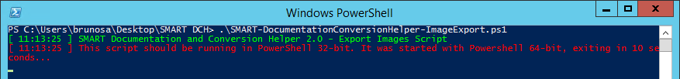

*This does not apply to the main script, which works with PowerShell 64-bit*

1. If you did not specific the **$OrchestratorExtensionsDir** parameter, a window will popup asking you to specify the location for the Orchestrator extensions.

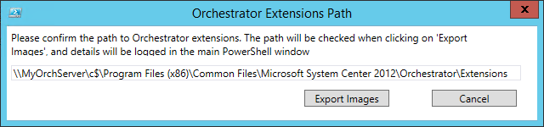

If you used the default installation path for Orchestrator, you may just have to update the string “**MyOrchServer**” computer name to your own server name.

1. When clicking on « **Export Images** », the main PowerShell window should display the progress as thumbnails are exported :

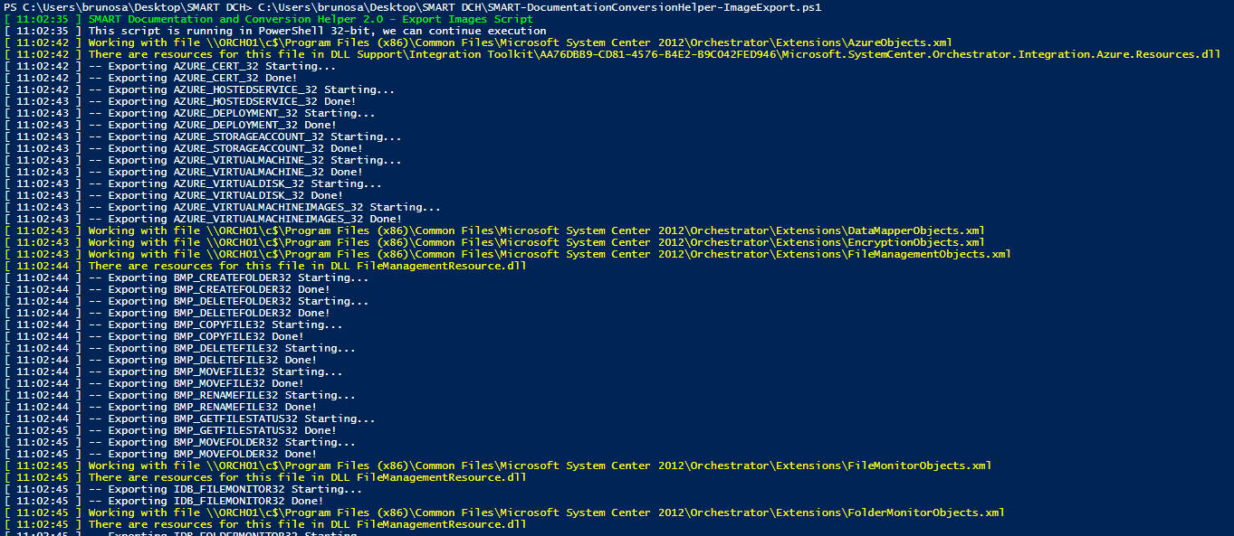

***Note:*** *For successful export, you might need the Visual C++ 2010 redistributable package. The prerequisites section includes some download links. If this package is not installed, you might see this error – Even after installing the package, this error can persist for a few integrations packs from CodePlex, esplained in the “Known Issues” section later in this document*

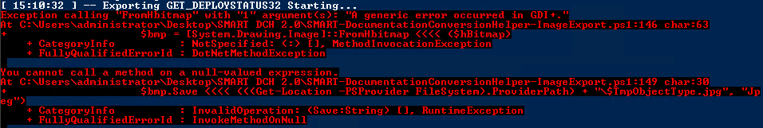

Any Runbook using an activity for which the thumbnail could not be exported will be displayed using the “default” thumbnail shipping with the tool (“default.jpg”). For that reason, image export is not technically mandatory, but recommended for better and more readable output in the Word and Visio files.

***Note:*** *The tool will try to warn you of two situation related to image export:*

* *If the numbers of images in the local folder are lower than 10, it probably means you have not run the image export script (Note: screenshot is likely truncated to fit in this Word document)*



* *If the “default.jpg” image cannot be found in the local folder, the script might encounter errors when trying to export to Visio or Word (Note: screenshot is likely truncated to fit in this Word document)*



# How to use the tool

1. Launch the tool (**SMART-DocumentationConversionHelper.ps1**) by running it with PowerShell or the PowerShell ISE. The tool should be able to run on any machine, and without any parameters.
   * By default, it will just time out if you do not have an Orchestrator DB locally (it defaults to localhost), and will give you the option to select another server in the user interface.
   * You can also set the DB server via the command line (-DBServer switch), or in the script itself.
   * Instance names can be specified using the « Server\Instance » syntax.
   * Finally, the tool also remembers the last server used, thanks to a configuration file automatically saved/loaded.
2. Select a Runbook. The tree view in the user interface is the same as in the Orchestrator Runbook Designer. Runbooks are displayed in blue, folders are displayed in black.
3. Select your export options – see more details below. Depending on Word 2013 and Visio 2013 being present, the option to export to Word and Visio will or will not be provided
4. Just click « **Export** »!

## Details on the different options in the user interface

* **“Visio Settings…”** allows you to view and update the settings specifics to Visio 2013. They are automatically saved in the same configuration file as the database server details, and reused when reopening the tool
* **“[Images Export]”** counts the number of JPEG files in the same directory as the tool. At minimum, you should have one picture, the default one used by the tool when it cannot find the thumbnail for the activity type it is exporting to Visio or Word. Run the **SMART-DocumentationConversionHelper-ImageExport.ps1** script to go through the export process at least once and populate the JPEG files.
* Visio options: If **“Save and Close”** is checked, the VSDX file is saved to the local directory, instead of being kept open. By default it is not checked, so you can manipulate the diagram layout before saving it yourself. **“Group Thumbnails”** is checked by default and groups activities and thumbnails and activities for easy manipulation.
* Word options: If **“Save and Close”** is checked, the DOCX file is saved to the local directory, instead of being kept open.
* PowerShell options: If **“Save and Close”** is checked, the PS1 file is saved to the local directory, instead of opening ISE and leaving it open with the script. **“Skeleton Only”** mode is explained in the « overview » section at the beginning of this document.

***Note:*** *Options for Visio, Word and PowerShell are only available after checking the corresponding export box. For example, you will not be able to choose “Save and Close” for Word, if you have not select the “Export to Word” option.*

# A few sample outputs

## Example 1

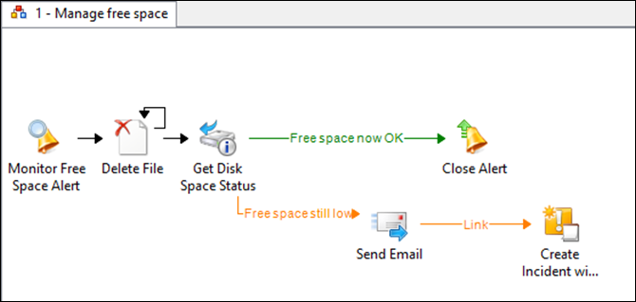

*Orchestrator Runbook*

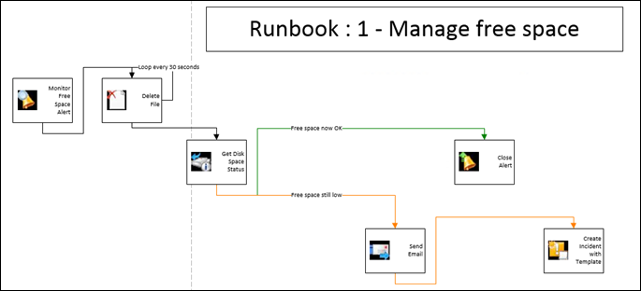

*Visio Export*

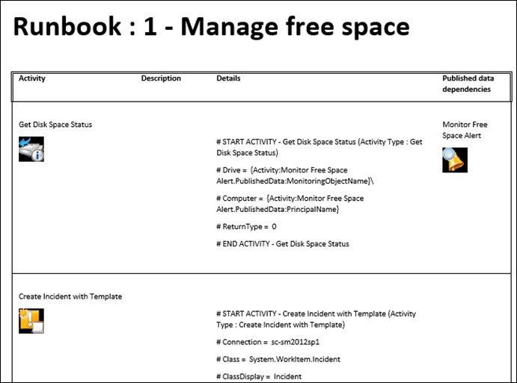

*Word Export*

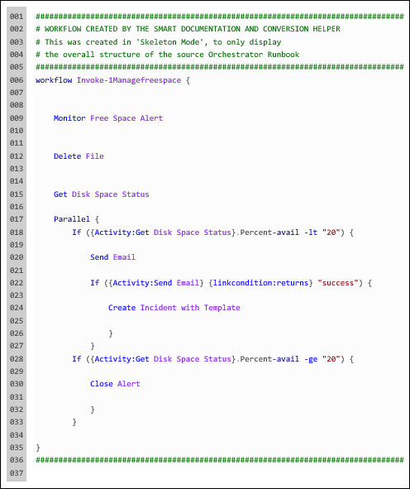

*PowerShell Export (skeleton mode)*

## Example 2

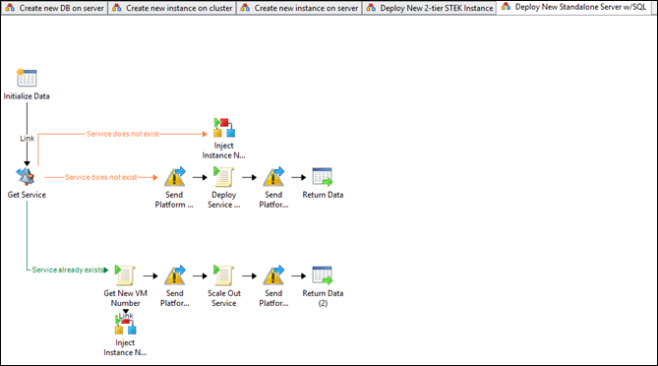

*Orchestrator Runbook*

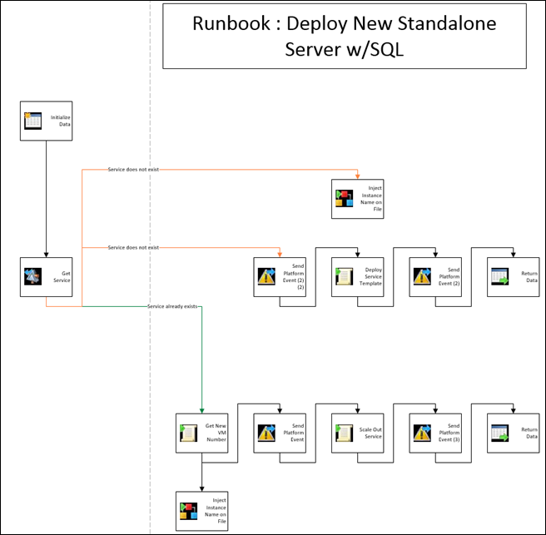

*Visio Export*

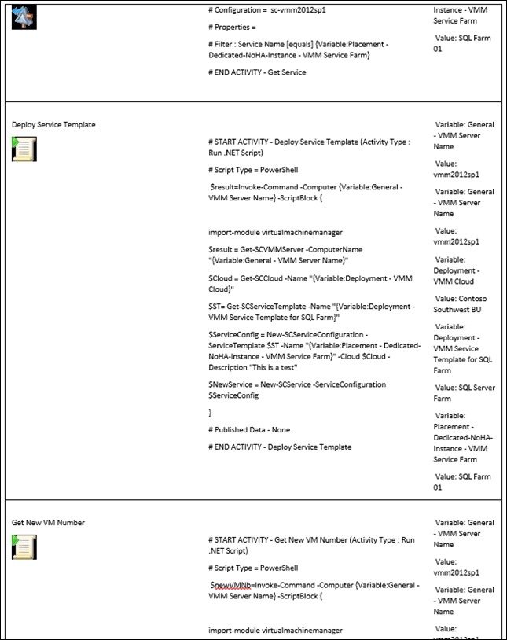

*Word Export (extract from the middle of the file)*

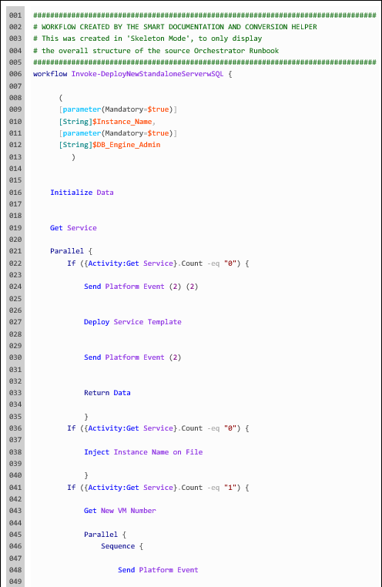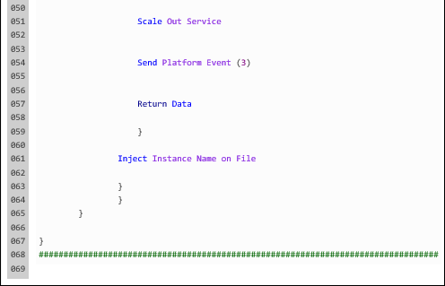

*PowerShell Export (skeleton mode)*

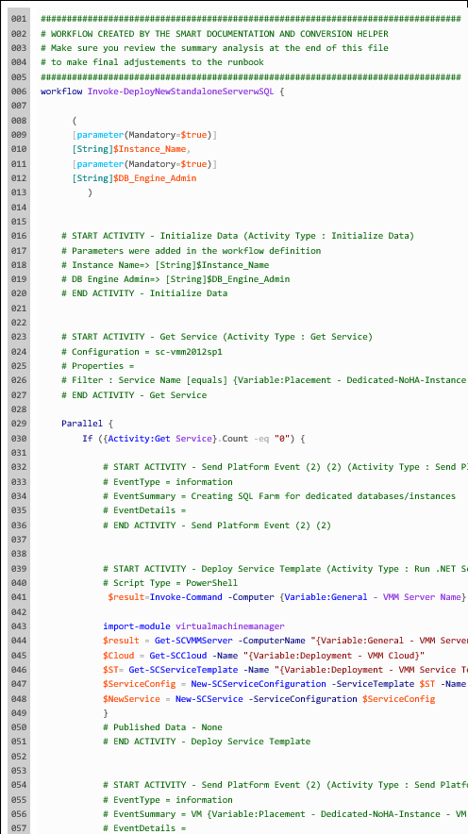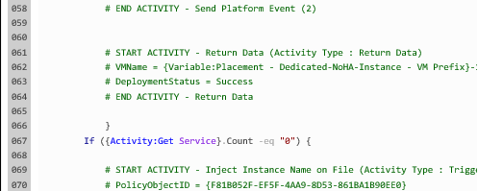

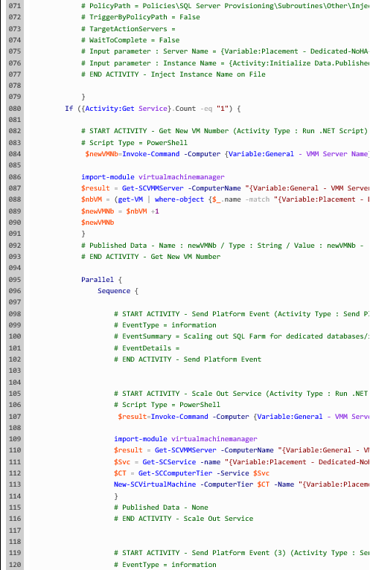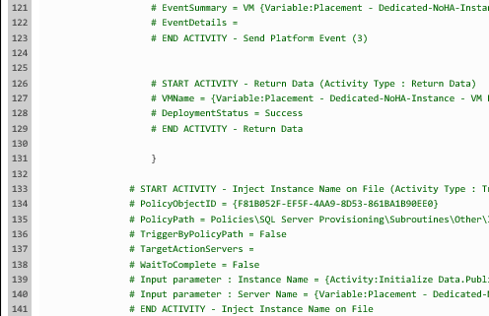

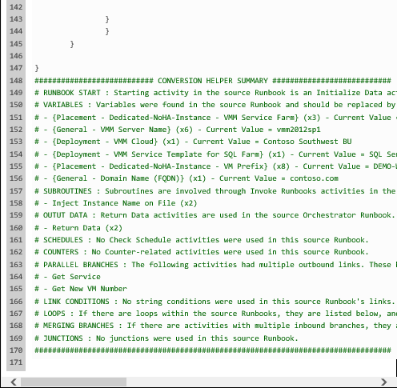

*PowerShell Export (full mode) – It has been cropped on the left side, this* [*blog post*](http://blogs.technet.com/b/privatecloud/archive/2014/05/08/updated-tool-smart-documentation-and-conversion-helper-for-your-orchestrator-runbooks.aspx) *includes the full export.*

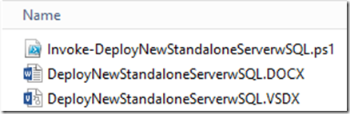

*The 3 saved exports*

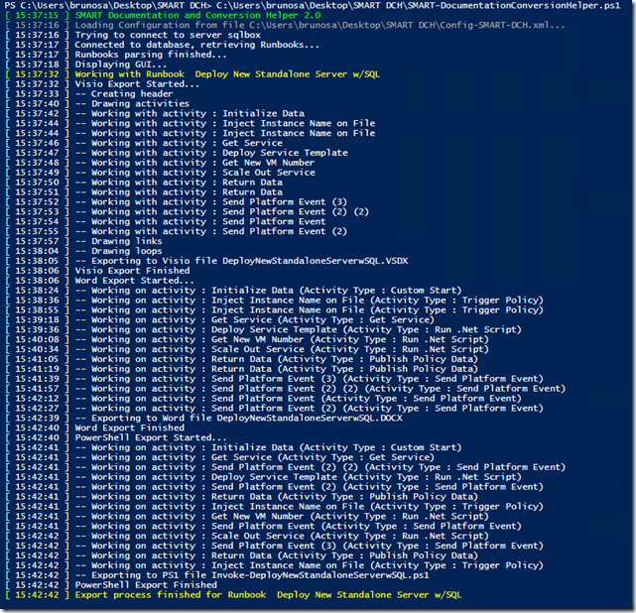

*PowerShell command output – the Visio and PowerShell exports are the fastest*

# Known issues

1. Exporting images for some community integration packs – including some versions of the “Data Manipulation”, “SharePoint” and “Exchange Management” from CodePlex – may not work and may generate this error in the script – but still continue with exporting the ones it can

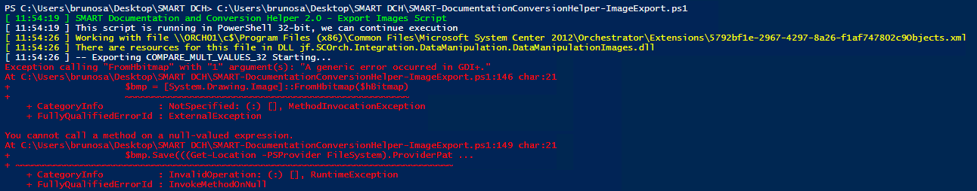

This is because, in their current build, accessing the associated DLLs requires a debug version of the runtime DLLs (e.g.MSVCR100D.DLL), only available within Visual Studio. However, SMART Documentation and Conversion Helper should not fail when generating diagrams including activities from these Integration Packs: their images should be replaced by the default image. Incidentally, exporting from a machine where Visual Studio is installed should work for these Integration Packs.

1. With the move to PowerShell and using COM to automate Word, Word Export tend to be slower than Visio Export and PowerShell Export. That being said, leveraging the PowerShell export gives you similar insight into the activities, with the added benefits of visualizing the “flow” and getting into a SMA mindset.

# Version history

**SMART Documentation and Conversion Helper**

* Version 2.01 – Minor update, nearly unchanged
  + Updated the SQL query in Word export to exclude deleted objects
  + Added logic consistent with other SMART tools (automatic elevation, right-click to run script from Windows Explorer window)
* Version 2.0 – Initial release, merge of Orchestrator Visio and Word Generator and SMART Runbook Conversion Helper.
  + This is now fully provided as a Powershell script, making it easy for anyone to update and enhance the script as needed
  + Some changes related to Visio and Word export, compared to the previous separate tools
    - SMART Documentation and Conversion Help 2.0 assumes a default set of settings for Visio, and you can update them using the “Visio Settings…” button.
    - Since it is usually only done once at the beginning, or only very rarely after that, the Image Export process – that retrieves the thumbnails used in Orchestrator Runbooks to include them in Visio and Word exports – has been made separate in its own script (SMART-DocumentationConversionHelp-ImageExport.ps1).

**SMART Runbook Conversion Helper - discontinued**

* Version 1.0 – Initial release

**Orchestrator Visio and Word Generator - discontinued**

* Versions 1.51 includes a few fixes and enhancements:
  + Adds a way to connect to a named instance without specifying the port (see “Working with SQL Server named instances” earlier in this document
  + Fixes a situation where the Visio export would fail when exporting Runbooks links, on a machine running non-English regional settings
  + Fixes an “index was out of range” issue in a specific situation with deleted objects still present in the Orchestrator database
  + Enhanced the tool so it would not fail when loops do not have a duration specified in the Runbook Designer.
* Version 1.5 adds
  + Support for Visio 2013 and Word 2013
  + More details in the Word document : Published data GUIDs are now replaced with actual names of the dependent activities, and also actual parameter names when exporting “Initialize Data” activities.
  + Visio exports now correctly excludes deleted activities
* Version 1.31 is a minor update to add support for custom SQL Server ports for the database. It also works with System Center 2012 SP1 Orchestrator. It also generates an EXPORT.LOG file in the same directory as the tool, to log information about the export process. Version 1.31 is also the last version to support Opalis Integration Server exports, running the tool on 32-bit machines, and using Visio 2010 / Word 2010.
* Version 1.3 adds the following features and enhancements:
  + Support for Orchestrator, as part of the System Center 2012 release. This was tested with the RC release of Orchestrator. Using the tool with Opalis Integration Server 6.x is still possible, both versions are supported by v1.3
* Version 1.2 adds the following features and enhancements:
  + Less restrictions and clearer requirements when exporting images from policies. All IPs shipping with the product should work now.
  + Usability enhancements thanks to a separate settings page with additional automatic checks about your configuration:
    - Is Visio installed or not
    - Detection of the extensions path while still providing the ability to override the detection (for installations on other volumes than C: for example)
    - Automatic listing of the databases
    - Automatic listing of the Visio stencils and callouts for the chosen VSS file, etc.)
    - Ability to choose the connectors attachments on the Visio objects (e.g. bottom->top or right-> left)
  + Adds a first version of Word document generation as well. The idea is to provide a companion document with more details about the policies, instead of piling more data in the Visio diagram itself

*Many thanks to Robert Hearn for his help and suggestions on the first two topics!*

* Version 1.01 added a few checks on the validity of specified paths in the UI, and better information on the thumbnails export step.
* Version 1.0 – Initial release